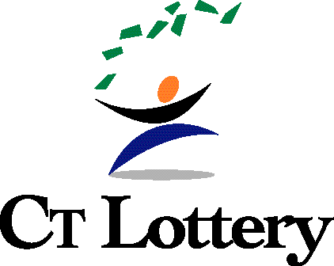

AGENDA

Regular Meeting of the

Board of Directors of the
Connecticut Lottery Corporation
to be held on
Thursday, December 9, 2021, at 12:00 p.m.
Public Dial-in Information
Dial-in: 1.866.767.7120
Passcode: 65418990#

- Welcome and Introductions
- Finance Committee Report
  - CliftonLarsonAllen Report on Audited Financial Statements for the year ended June 30, 2021
  - Executive Session: CliftonLarsonAllen (Optional)
- Approval of the October 14, 2021 Board Meeting Minutes
- Lottery and Sports Report
  - Financial Report (Mr. Granato)
- Marketing Report (Mr. Smith)
- Sports Betting Report (Mr. Walter)
- President’s Report (Mr. Smith)
- Committee Reports
- Executive Committee (Mr. Simmelkjaer)
- Audit Committee (Mr. Meehan)
- Finance Committee (Mr. Ezzes)
- Executive Session
  - Managers’ Compensation Recommendation
  - President & CEO’s Performance Review
  - Real Estate Recommendation
  - Pending Claims and Litigation: Civil Suit
- New Business
  - Discussion and action, if any, on items discussed during Executive Session
  - Review and Approval of Board Meeting Schedule for 2022
- Adjournment

Next Scheduled Meeting – Thursday, February 10, 2022, 12:00 noon

