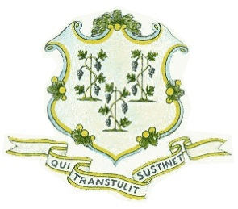
STATE OF CONNECTICUT
PUBLIC UTILITIES REGULATORY AUTHORITY

NOTICE OF MEETING
(June 28, 2021)

The Commissioners of the Public Utilities Regulatory Authority (Authority) will conduct a meeting, via remote access, on Monday, June 28, 2021, at 1:00 p.m. Access instructions are set forth below. The Authority’s meeting participants include Vice-Chairman John W. Betkoski, III, and Commissioner Michael A. Caron. Eversource participants will include: Joshua White, Mark Fangiullo, Lissette Andino, Jack Arsego, Kerry Britland & Beth Maldonado.

The purpose of the meeting is for Eversource to present information regarding its emergency preparedness.

Remote attendee access:
Join Zoom Meeting
https://zoom.us/j/92692741104?pwd=YXZHdXVIY29CUUFEcHBROUFRUDJUQT09
Meeting ID: 926 9274 1104
Passcode: PURA2021

The Connecticut Department of Energy and Environmental Protection is an Affirmative Action/Equal Opportunity Employer that is committed to complying with the requirements of the Americans with Disabilities Act. Please contact the case coordinator at laura.lupoli@ct.gov if you are seeking a communication aid or service, have limited proficiency in English, or require some other accommodation. If you wish to file an ADA or Title VI discrimination complaint, you may submit your complaint to Barbara Viadella or Cenit Mirabal, DEEP Office of Diversity and Equity at (860) 418-5910 or via email at deep.accomodations@ct.gov. In order to facilitate efforts to provide an accommodation, please request all accommodations as soon as possible following notice of any agency hearing, meeting, program or event.

Dated at New Britain, Connecticut, this 10th day of June, 2021.

PUBLIC UTILITIES REGULATORY AUTHORITY
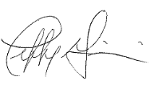
Jeffrey R. Gaudiosi, Esq.
Executive Secretary

Notice filed with the Secretary of the State on June 10, 2021.

