\DATE

Agenda of Regular Meeting
(Wednesday, November 29, 2017)

A Regular Meeting of a panel of Utility Commissioners and/or staff members of the Public Utilities Regulatory Authority (Authority) will be held at its offices Ten Franklin Square, New Britain, Connecticut on Wednesday, November 29, 2017, at 9:30 a.m., concerning the following:

- Consideration of the following proposed final decisions (REGULAR CALENDAR):

- Docket No. 17-06-27 – Application of GenConn Energy LLC for Establishment of 2018 Revenue Requirements (KCB/rrs)

- Consideration of the following proposed final decisions (CONSENT CALENDAR):

- Docket No. 07-03-27RE01 – Application of East Lyme Public Schools for a Capital Grant for Customer-Side Distributed Generation Resources – Termination of DG Grant Requirements (KCB/pmc)

- Docket No. 07-06-03RE01 – Application of Zygo Corporation for a Capital Grant for Customer-Side Distributed Generation Resources – Termination of DG Grant Requirements (KCB/pmc)

- Docket No. 17-02-49 - PURA Formalization of Small Cell Antenna Applicant Processes and Procedures to Construct Facilities in Connecticut’s Public Rights-of-Way – Motion No. 53 (CKB/jlb)

- Docket No. 17-02-49 - PURA Formalization of Small Cell Antenna Applicant Processes and Procedures to Construct Facilities in Connecticut’s Public Rights-of-Way – Motion No. 71 (CKB/jlb)

- Docket No. 17-02-49 – PURA Formalization of Small Cell Antenna Applicant Processes and Procedures to Construct Facilities in Connecticut’s Public Rights-of-Way – Motion No. 81 (CKB/jlb)

- Docket No. 17-02-49 PURA Formalization of Small Cell Antenna Applicant Processes and Procedures to Construct Facilities in Connecticut’s Public Rights-of-Way – Motion No. 83 (CKB/jlb)

- Docket No. 17-02-49 PURA Formalization of Small Cell Antenna Applicant Processes and Procedures to Construct Facilities in Connecticut’s Public Rights-of-Way – Motion No. 87 (CKB/jlb)

- Docket No. 17-02-49 – PURA Formalization of Small Cell Antenna Applicant Processes and Procedures to Construct Facilities in Connecticut’s Public Rights-of-Way – Motion No. 89 (Darien CT SC2) (CKB/jlb)

- Docket No. 17-02-49 PURA Formalization of Small Cell Antenna Applicant Processes and Procedures to Construct Facilities in Connecticut’s Public Rights-of-Way – Motion No. 91 (CKB/jlb)

- Docket No. 17-04-21 - Application of Specialty Wire & Cord Sets, Inc. for Qualification of 1 Gallagher Rd., Hamden, CT as a Class I Renewable Energy Source (CBK/dmd)

- Docket No. 17-07-28 - Application of BRT Barnbeck Place, LLC to Install and Use a Water Submetering System at 398A and 398B Federal Road, Brookfield, CT 06804 (BCK/ms)

- Docket No. 17-08-09 - Application of SolarCity Corporation for Qualification of 5C Sugar Hollow Rd. (Whole Foods Market), Danbury, CT as a Class I Renewable Energy Source (KCB/dmd)

- Docket No. 17-08-11 – Application of Curtis Packaging Corp. for Qualification of 44 Berkshire Road (System 1), Sandy Hook, CT as a Class I Renewable Energy Source (KCB/dmd)

- Docket No. 17-08-12 – Application of Curtis Packaging Corp. for Qualification of 44 Berkshire Road (System 2), Sandy Hook, CT as a Class I Renewable Energy Source (KCB/dmd)

- Docket No. 17-08-15 – Application of Bloom Energy Corporation for Qualification of 20 Middletown Ave., North Haven, CT as a Class I Renewable Energy Source (BKC/dmd)

- Docket No. 17-09-14 – Application of Mark Kanevsky for Qualification of 33 Woodside Dr., Woodbridge, CT as a Class I Renewable Energy Source (BCK/dmd)

- Docket No. 17-09-25 – Application of James Schwartz for Qualification of 44 Ferry Road, Hadlyme, CT as a Class I Renewable Energy Source (CBK/dmd)

- Docket No. 17-09-26 – Application of Stone Resource, LLC for Qualification of 234 Middle Street, Middletown, CT as a Class I Renewable Energy Source (CBK/dmd)

- Docket No. 17-09-28 – Application of CT Solar Lease 3, LLC for Qualification of 10 Riverview Drive, Danbury, CT as a Class I Renewable Energy Source (BCK/dmd)

- Docket No. 17-09-29 – Application of CT Solar Lease 3, LLC for Qualification of 150 Prospect Street (Wethersfield United Methodist Church), Wethersfield, CT as a Class I Renewable Energy Source (BCK/dmd)

- Docket No. 17-09-31 – Application of CT Solar Lease 3, LLC for Qualification of 40 Gold Street (Sacred Heart Church), Greenwich, CT as a Class I Renewable Energy Source (BCK/dmd)

- Docket No. 17-09-32 – Application of CT Solar Lease 3, LLC for Qualification of 38 Gold Street (Sacred Heart Parish Office/Rectory), Greenwich, CT as a Class I Renewable Energy Source (BCK/dmd)

- Docket No. 17-09-35 - Application of Accel International Holdings, Inc. for Qualification of 508A North Colony Road, Meriden, CT as a Class I Renewable Energy Source (BCK/dmd)

- Docket No. 17-09-38 – Application of PAF Commercial Realty LLC for Qualification of 353 Route 165, Preston, CT as a Class I Renewable Energy Source (CBK/dmd)

- Docket No. 17-09-39 – Application of KNOX, Inc. for Qualification of 75 Laurel Street, Hartford, CT as a Class I Renewable Energy Source (CBK/dmd)

- Docket No. 17-09-40 – Petition for Approval of Method and Manner of Construction and Permission to Energize the New Plumtree Substation to Brookfield Junction Line (1887) (KCB/jjj)

The public may call the Authority’s offices, at (860) 827-1553, option 4 (using a touch tone phone), commencing each day from 7:30 a.m., to be advised as to whether the regular meeting has been cancelled or postponed due to inclement weather. The Connecticut Department of Energy and Environmental Protection is an
Affirmative Action and Equal Opportunity Employer that is committed to complying with the Americans with Disabilities Act. To request an accommodation contact us at (860) 418-5910 or deep.accommodations@ct.gov.

PUBLIC UTILITIES REGULATORY AUTHORITY
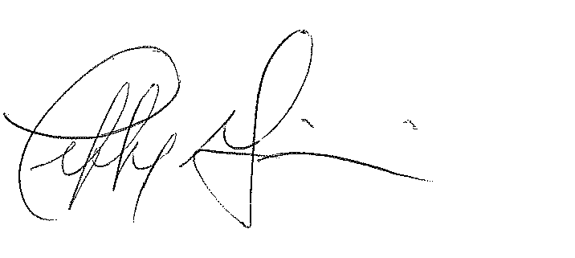
Jeffrey R. Gaudiosi, Esq.
Executive Secretary

Agenda filed with the Secretary of State on November 22, 2017.

