\DATE

Agenda of Regular Meeting
(Wednesday, March 7, 2018)

A Regular Meeting of a panel of Utility Commissioners and/or staff members of the Public Utilities Regulatory Authority (Authority) will be held at its offices at Ten Franklin Square, New Britain, Connecticut on Wednesday, March 7, 2018, at 9:30 a.m., concerning the following:

- Consideration of the following proposed final decisions (CONSENT CALENDAR):

- Docket No. 10-12-02 - Application of Yankee Gas Services Company for Amended Rate Schedules – Motion No. 62 (KBC/kp)

- Docket No 12-06-13 - Application of UTC Power Corp for Qualification of St. Francis Hospital, Mt. Sinai Campus as a Class I Renewable Energy Source – Reopening (BCK/dmd)

- Docket No. 16-07-20 - Annual Review of Connecticut Electric Suppliers’ and Electric Distribution Companies’ Compliance with Connecticut’s Renewable Energy Portfolio Standards in the Year 2015 and Docket No. 13-03-09 -Application of Mega Energy of New England, LLC for an Electric Supplier License (CB/mlh)

- Docket No. 16-07-20 - Annual Review of Connecticut Electric Suppliers’ and Electric Distribution Companies’ Compliance with Connecticut’s Renewable Energy Portfolio Standards in the Year 2015 and Docket No. 14-03-03 - Application of Major Energy Electric Services, LLC for an Electric Supplier License (CB/mlh)

- Docket No. 17-02-49 - PURA Formalization of Small Cell Antenna Applicant Processes and Procedures to Construct Facilities in Connecticut’s Public Rights-of-Way – Motion No. 107 (CKB/pap)

- Docket No. 17-02-49 - PURA Formalization of Small Cell Antenna Applicant Processes and Procedures to Construct Facilities in Connecticut’s Public Rights-of-Way – Motion No. 108 (CKB/pap)

- Docket No. 17-08-18 - Application of Berry Patch III, LLC to Install a Water Submetering System at 175 Oakland Road (7 Bldgs.) South Windsor, CT (BKC/ms)

- Docket No. 17-11-09 - Application of Olender's Inc. for Qualification of 704 Talcottville Rd., Vernon, CT as a Class I Renewable Energy Source (CBK/dmd)

- Docket No. 17-12-05 - Application of Sand Road Animal Hospital, LLC for Qualification of 136 Sand Road (Clinic), Falls Village, CT as a Class I Renewable Energy Source (BCK/dmd)

- Docket No. 17-12-09 - Application of Destefano & Chamberlain, Inc. for Qualification of 50 Thorpe St., Fairfield, CT as a Class I Renewable Energy Source (BCK/dmd)

- Docket No. 17-12-12 - Application of Barry Price for Qualification of 166 Old Huckleberry Road, Wilton, CT as a Class I Renewable Energy Source (CBK/dmd)

- Docket No. 17-12-13 - Application of Star Power Energy, LLC for Qualification of 4 Campus Dr. (Town of Madison Gym), Madison, CT as a Class I Renewable Generation Facility (BCK/dmd)

- Docket No. 17-12-18 - Application of CT Solar Lease 3, LLC for Qualification of 21 Arch Bridge Road (Wellspring - Arch Bridge School - Dodds Family Center), Bethlehem, CT as a Class I Renewable Energy Source (CBK/dmd)

- Docket No. 18-01-07- Application of Windham Solar, LLC for Qualification of 948 Windham Rd. (Jefferson Solar), North Franklin, CT as a Class I Renewable Energy Source (CBK/dmd)

The public may call the Authority’s offices, at (860) 827-1553, option 4 (using a touch tone phone), commencing each day from 7:30 a.m., to be advised as to whether the regular meeting has been cancelled or postponed due to inclement weather. The Connecticut Department of Energy and Environmental Protection is an Affirmative Action and Equal Opportunity Employer that is committed to complying with the Americans with Disabilities Act. To request an accommodation contact us at (860) 418-5910 or deep.accommodations@ct.gov.

PUBLIC UTILITIES REGULATORY AUTHORITY
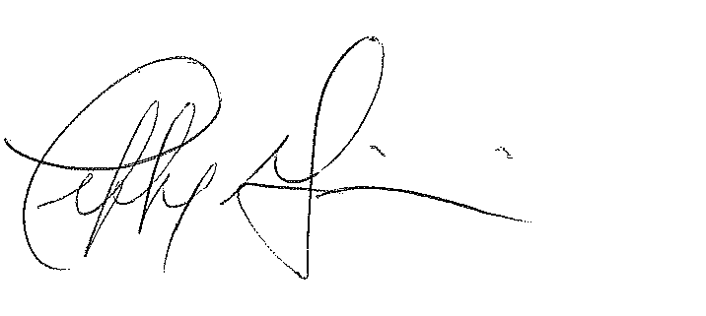
Jeffrey R. Gaudiosi, Esq.
Executive Secretary

Agenda filed with the Secretary of State on February 28, 2018 and March 5, 2018.

