May 1, 2018

Office of the Secretary of the State
30 Trinity Street
Hartford, CT 06106

RE: Special Meeting of the Water Planning Council – Site Visit

In accordance with the provisions of Section 1-225(b) of the Connecticut General Statutes, the Water Planning Council (WPC) announces a Special Meeting of the WPC members and/or their designees, to be held on Tuesday, May 8, 2018. The site visit will begin at 10 AM at the O Biddle Pass in Plainville. It is expected to last 2 – 2.5 hrs. and will be over rough terrain. Participants should wear sturdy hiking shoes or boots and a walking stick is recommended. Precautions against ticks should be taken. There will be no discussion of the site, other than the most basic directions. No public comment will be taken. Some members and/or staff of the Council on Environmental Quality also are planning to attend.

All interested persons are hereby notified that public comment will not be heard at the meeting. Waivers of liability, required to enter the properties, will be provided and must be signed prior to participating in the site visit. It is requested that members of the public planning to attend the site visit, notify the Public Utilities Regulatory Authority via email at Gail.Lucchina@ct.gov.

Sincerely,

Public Utilities Regulatory Authority
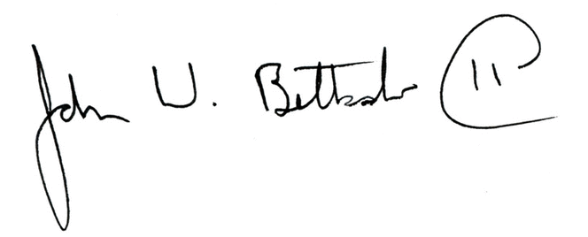
John W. Betkoski, III
Chairperson, Water Planning Council

