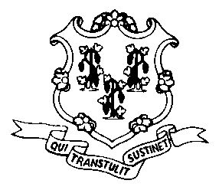 | State of Connecticut  Division of Public Defender Services
 | OFFICE OF CHIEF PUBLIC DEFENDER  55 FARMINGTON AVENUE – 8TH FLOOR  HARTFORD, CONNECTICUT 06105  Telephone - 860-509-6403  Fax - 860-509-6495 | ATTORNEY JOHN R. DAY  CHIEF PUBLIC DEFENDER  john.day@pds.ct.gov

AGENDA
PUBLIC DEFENDER SERVICES COMMISSION

Meeting of March 3, 2026

Office of Chief Public Defender
55 Farmington Avenue, Rooms 1008/1011
Hartford, CT 06105
4:30 p.m.

- Approval of Minutes – February 17, 2026 (Special)

- Old Business

- Strategy and Negotiations with Respect to Collective Bargaining

- New Business

- New Job Specification – PD Interpreter
- Income Eligibility Guidelines for Public Defender Services - 2026

- Report of Chief Public Defender

- Commission Correspondence

- Approval of Authorizations to Incur Expenses

- Appointments

- Transfers, Retirements and Resignations

- Reclassifications

- Reappointments & Permanent Statuses

- Outside Employment Requests

- Educational Leave Requests

- Executive Session – Commission Correspondence, Authorizations to Incur Expenses, Appointments, Reclassifications, Reappointments & Permanent Statuses, Outside Employment Requests, Educational Leave Requests, Strategy and Negotiations with Respect to Collective Bargaining, and Litigation Involving the Commission.

