.

STATE OF CONNECTICUT DEPARTMENT OF CONSUMER PROTECTION
Via Email: bobbymaraj@aol.com
In the matter of:

Bobby P. Maraj, Permittee Case: 2026-77
Rumaj Lounge Permit: LCA.8756
216 Crown Street Backer: B&M Nitelife LLC New Haven, CT 06510

PURSUANT TO CONN. GEN. STAT. § 30-43 AS AMENDED:

You and a member of the backer limited liability company are summoned to appear for a hearing regarding an application for a liquor permit for Rumaj Lounge at 316 Crown Street, New Haven, CT 06510, before the Department of Consumer Protection, on Thursday, May 21, 2026, from 9:30 a.m. to 5:00 p.m. The hearing will be conducted remotely. Instructions on how to connect to the Teams platform is attached.
You will be required to furnish facts and evidence in support of the application relative to suitability of person and/or place as provided by Chapter 545 of the Connecticut General Statutes and the Regulations of the Connecticut State Agencies.

THIS HEARING IS BEING HELD ON A QUESTION OF:
Issue #1: Sec. 30-39(c) of the Connecticut General Statutes. Applications for permits, renewals. (Remonstrance.)

The respondent has waived, in writing, his opportunity for a compliance meeting.

PLEASE BE ADVISED THAT YOU WILL BE EXPECTED TO APPEAR WHEN YOUR HEARING IS CALLED BY THE COMMISSION. FAILURE TO APPEAR AT THE DESIGNATED TIME MAY RESULT IN A DEFAULT.

If you have any questions regarding this notice, please contact Tanya A. Washington of the Department of Consumer Protection’s Legal Division at (860) 241-8475 fax at (860) 706-1332 or email at tanya.washington@ct.gov.

Dated at Hartford, Connecticut, this 23rd day of April 2026.

STATE OF CONNECTICUT
DEPARTMENT OF CONSUMER PROTECTION

M. Caitlin Anderson
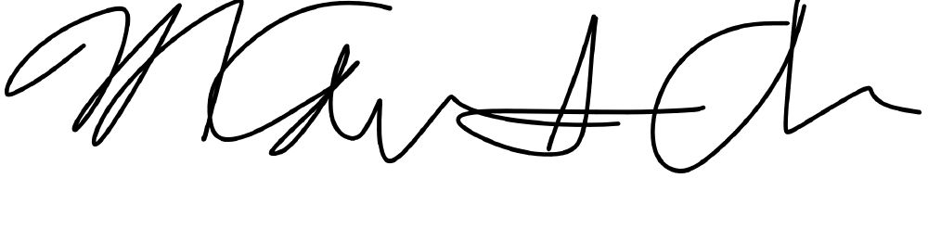
Chief of Legal and Regulatory Affairs

c: Via Email: christineekimward@gmail.com

