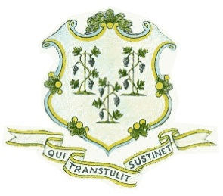
STATE OF CONNECTICUT
PUBLIC UTILITIES REGULATORY AUTHORITY

NOTICE OF MEETING
(February 8, 2019)

The Utility Commissioners of the Public Utilities Regulatory Authority (Authority) will conduct a meeting at the Authority’s offices, Commissioner’s Conference Room, at Ten Franklin Square, New Britain, Connecticut on Friday, February 8, 2019, at 10:00 a.m. The meeting participants include Authority Acting Chair John W. Betkoski, III, Commissioner Michael A. Caron, and members of the Authority’s staff. Other participants, from Eversource Energy, include: Theresa Hopkins-Staten, Troy Dixon, and Al Langland. Also in attendance will be a member of the Work and Asset Management (WAM) Project Team. The purpose of the meeting is provide an overview of WAM and will include a discussion of employee engagement and project benefits.

The public may call the Authority’s offices, at (860) 827-1553, option 4 (using a touch tone phone), commencing each day from 7:30 a.m., to be advised as to whether this meeting has been cancelled or postponed due to inclement weather. Persons with special needs in accordance with the Americans with Disabilities Act who wish to attend this noticed event should contact the Connecticut Department of Energy and Environmental Protection at (860) 418-5910 or deep.accommodations@ct.gov.

Dated at New Britain, Connecticut, this 6th day of February, 2019.

PUBLIC UTILITIES REGULATORY AUTHORITY
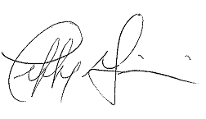
Jeffrey R. Gaudiosi, Esq.
Executive Secretary

Notice filed with the Secretary of the State on February 6, 2019.

