Notice of Cancellation of Water Planning Council Meeting
(April 7, 2020)

The Water Planning Council (WPC) announces that the regular meeting of the Water Planning Council, scheduled for April 7, 2020, at 1:30 p.m., at the offices of the Public Utilities Regulatory Authority, Ten Franklin Square, New Britain, Connecticut, is hereby cancelled.

Dated at New Britain, Connecticut, this 26th day of March, 2020.

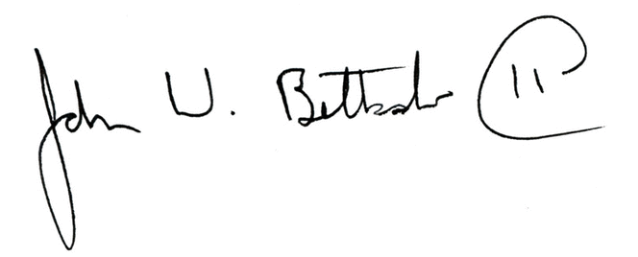
John W. Betkoski, III
Chairman, Water Planning Council

Notice filed with the Secretary of State on March 26, 2020.

