Notice of Cancellation of Water Planning Council Meeting
(August 4, 2020)
and
Notice of September 1, 2020 Water Planning Council Meeting

The Water Planning Council (WPC) announces that the regular meeting of the Water Planning Council, scheduled for August 4, 2020, at 1:30 p.m., via remote access, is hereby cancelled.

The next regular meeting of the WPC is scheduled for September 1, 2020, at 1:30 p.m. Due to Governor Lamont’s “Stay Safe, Stay Home” policy, the meeting on September 1, 2020 will be conducted via remote access through the Zoom platform. Participants may access the meeting through the following link: https://ctdeep.zoom.us/j/91927394991 or by dialing +1 646 876 9923.

Should the Governor’s policy change prior to September 1, 2020, the WPC will provide information on the location of the meeting.

Dated at New Britain, Connecticut, this 3rd day of August, 2020.

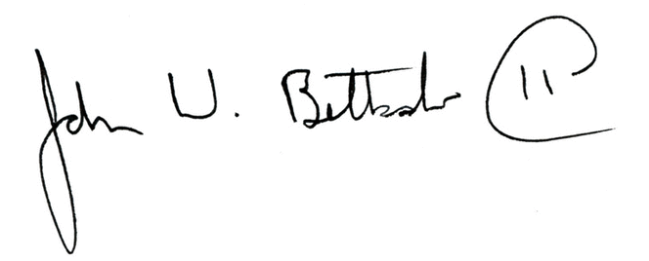
John W. Betkoski, III
Chairman, Water Planning Council

Notice filed with the Secretary of State on August 3, 2020.

