Notice of Rescheduled Water Planning Council Meeting
(September 2, 2020)

The Water Planning Council (WPC) hereby announces that the September 1, 2020 WPC meeting is rescheduled to Wednesday, September 2, 2020, at 2:00 p.m., via remote access.

Dated at New Britain, Connecticut, this 31st day of August, 2020.

Sincerely,

PUBLIC UTILITIES REGULATORY AUTHORITY
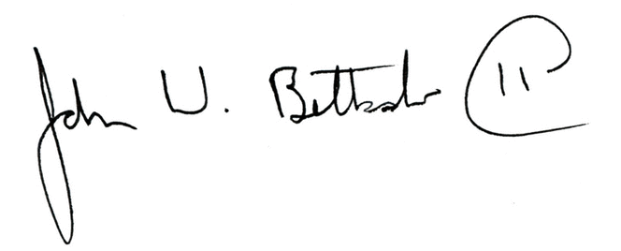
John W. Betkoski, III
Chairman, Water Planning Council

Notice filed with the Secretary of State on August 31, 2020.

