Notice of Cancellation of Water Planning Council Meeting
(December 1, 2020)
and
Notice of January 5, 2021 Water Planning Council Meeting

The Water Planning Council (WPC) announces that the regular meeting of the Water Planning Council, scheduled for December 1, 2020, at 1:30 p.m., via remote access, is hereby cancelled.

The next regular meeting of the WPC is scheduled for January 5, 2021, at 1:30 p.m. Due to Governor Lamont’s “Stay Safe, Stay Home” policy, the meeting on January 5, 2021 will be conducted via remote access through the Zoom platform. Participants may access the meeting through the following link: https://ctdeep.zoom.us/j/98340041567 or by dialing +1 646 876 9923.

Dated at New Britain, Connecticut, this 27th day of November, 2020.

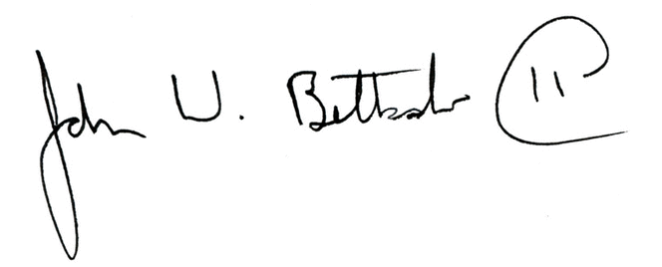
John W. Betkoski, III
Chairman, Water Planning Council

Notice filed with the Secretary of State on November 27, 2020.

