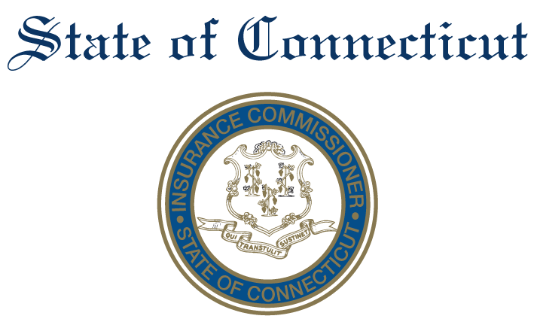

Advisory Council on Technology

February 4th, 2020
11:00AM-12:00PM

Department of Insurance
153 Market Street (7th Flr.)
Hartford, CT 06142
Conference Room 701

AGENDA
- Introductions

- Explore Subcommittee/topical area options, below are examples:

  - Consumer Data (Protection/Ownership)
  - Enabling Safe Innovation
  - Regtech

- Charges and goals of each Subcommittee
- Determine membership and next steps
- Discuss next meeting schedule.

