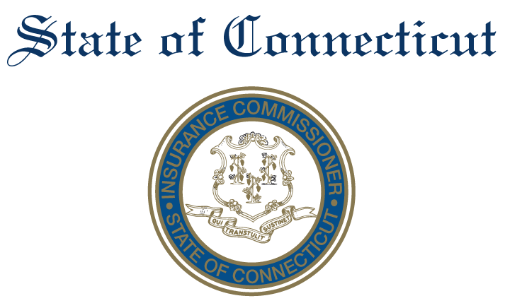

**Advisory Council on Regulation**

**Subcommittee on RegTech**

DATE: Monday, June 1st, 2020

TIME: 12:00

**AGENDA**

1. Introductions:

Chairperson, Maria Filipakis, [maria@topsidegroupllc.com](mailto:maria@topsidegroupllc.com)

Henry T. French Jr., [Henry7french@outlook.com](mailto:Henry7french@outlook.com)

Stacey Brown, [stacey.brown@insurtechhartford.com](mailto:stacey.brown@insurtechhartford.com)

Susan Winkler, [swinkler@metrohartford.com](mailto:swinkler@metrohartford.com)

Elizabeth Menke, [emenke@blockchainct.org](mailto:emenke@blockchainct.org)

1. Discussion:

Discussion with key members of the department to understand all the components of the insurance department, processes in place (including technology), and priority areas where technology may be most helpful. In addition, discussion of how the department collects, analyzes, and synthesizes data from consumers and carriers and what, if any, input it has received from the NAIC.

Potential areas of discussion/opportunities may include:

* Consumer complaints
* Regulatory (statutory) reporting
* Fraud detection and prevention
* Counterparty screening (for financial fraud, trade sanctions, money laundering, corruption)
* Governance Risk and Compliance tools
* Data Privacy
* Cyber regulation compliance/enforcement
* CID’s procedures for engaging vendors

1. Review:

Review the regtech subcommittee’s charge to determine if it needs to be modified or clarified in any way.

1. Determine next steps:

Identify additional topics, any material to be reviewed, and meetings to be scheduled.

1. Discuss next meeting schedule:

Set date for next meeting.