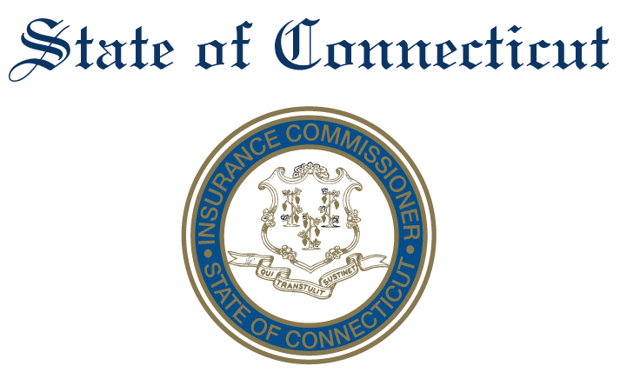

Agenda Advisory Council on Technology
November 19, 2020
1:00 - 2:00
AGENDA

- 1:00 – 1:05 Welcome
- 1:00 – 1:15 Regtech Subcommittee: report out, discussion, next steps
- 1:15- 1:35 Enable Innovation Subcommittee: report out, discussion, next steps
- 1:35- 1:55 Consumer Data Subcommittee: report out, discussion, next steps
- 1:55 – 2:00 Discuss next steps.
- 2:00 Adjourn

To Join the Meeting:
Microsoft Teams meeting
Join on your computer or mobile app
Click here to join the meeting
Or call in (audio only)
+1 860-840-2075,,259248325# United States, Hartford
Phone Conference ID: 259 248 325#
Find a local number | Reset PIN

