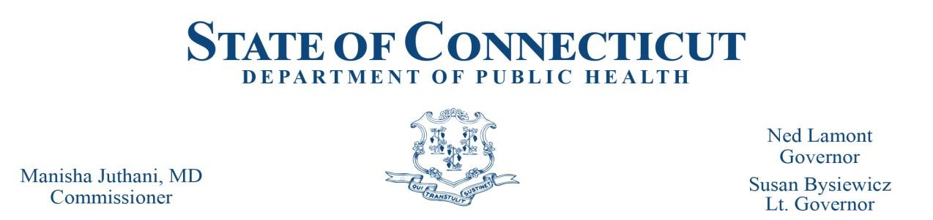

Scope of Practice Review Committee

Doula Training Program Review Committee Meeting

October 10, 2024

|  |  |  |  |  |  |  |
| --- | --- | --- | --- | --- | --- | --- |
| October 10, 2024 **Voting Members Present:** SciHonor Devotion, Selina Osei, Katherine Villeda, Precious Price, Traci McComiskey, Alyssa Herron, Whitley Mingo | | | | | | |
| **Meeting Date** | **Meeting Type** | **Motion** | **Motion Made By** | **Seconded By** | **Abesentions (A) Nays (N)** | **Decisions** |
| 10/10/24 | Monthly Meeting | The committee reviewed and approved the 2025 meeting schedule dates. | Traci McComiskey | SciHonor Devotion | None | Approved |
| 10/10/24 | Monthly Meeting | The committee reviewed and approved the required minimum number of Doula Core Curriculum training hours per domain. The required number of training hours per domain approved are as follows: **Pregnancy & Childbirth**: 12, **Postpartum Recovery and Newborn Period:** 10, **Expected and Unexpected Pregnancy Outcomes:** 7, **Promote Health Equity**: 4, **Promote Racial Equity**: 4, **Understanding Role in Advocacy**: 4, **Professional Standards:** 4. | Alyssa Herron | Traci McComiskey | None | Approved |
| 10/10/2024 | Monthly Meeting | The committee reviewed and approved the following Doula Training Organization Instructor Qualifications: The instructor is required to have been a Doula for 7 years AND has been a Certified Childbirth Educator for 3 years, for a total of 10 years overall.  The committee reviewed and approved to remove the requirement that the Doula Training Organization Instructor Qualification is required to be certified through CT Department of Public Health as a Doula in good standing. | Traci McComiskey | SciHonor Devotion | None | Approved |